Bangladesh Medical Association (BMA)
List of Life Member-5
38. BMA Meherpur Branch

Sl No | Voter No | Voter Details
1 | Voter No  LM-3800001  No Image | DR. SAYED ANISUR RAHMAN  F/Name: Late Syed Md. Yusuf  M/Name:  BM & DC Reg. No:  NID:  Cell:  Address: N/A  Blood Group:
2 | Voter No  LM-3800002 | DR. JAGADISH PROSHAD AGARWALLA  F/Name: Late Sachita Nanda Agarwalla  M/Name: Late Santi Devi Agarwalla  BM & DC Reg. No: 25660  NID: 5728706116799  Cell: 01711192185  Address: Sonolab Hospital Road, Meherpur  Blood Group: B+
3 | Voter No  LM-3800003  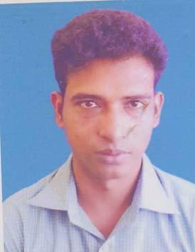 | DR. MD. MONIRUL KABIR SHAOWN  F/Name: Late kamrul Islam  M/Name: Mrs. Akhter Banu  BM & DC Reg. No: 46705  NID: 7311519800331  Cell: 01730427068  Address: Mukherjy Para, Post: Meherpur, PS+Dist: Meherpur  Blood Group: B+
4 | Voter No  LM-3800004  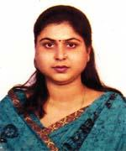 | DR. SAMPA DEVI SARDA  F/Name: Satya Narayan Sarda  M/Name: Rameshwari Devi Sarda  BM & DC Reg. No: 34056  NID: 3728706116801  Cell: 01715166738  Address: Sonolab Hospital Road, Meherpur  Blood Group: A+
5 | Voter No  LM-3800005 | Dr. Bipul Kumar Biswas  F/Name: LAte Madhob Chandra Biswas  M/Name: Tribeni Biswas  BM & DC Reg. No: 25881  NID: 2693623786671  Cell: 01733680302  Address: General Hospital Meherpur  Blood Group: B+

